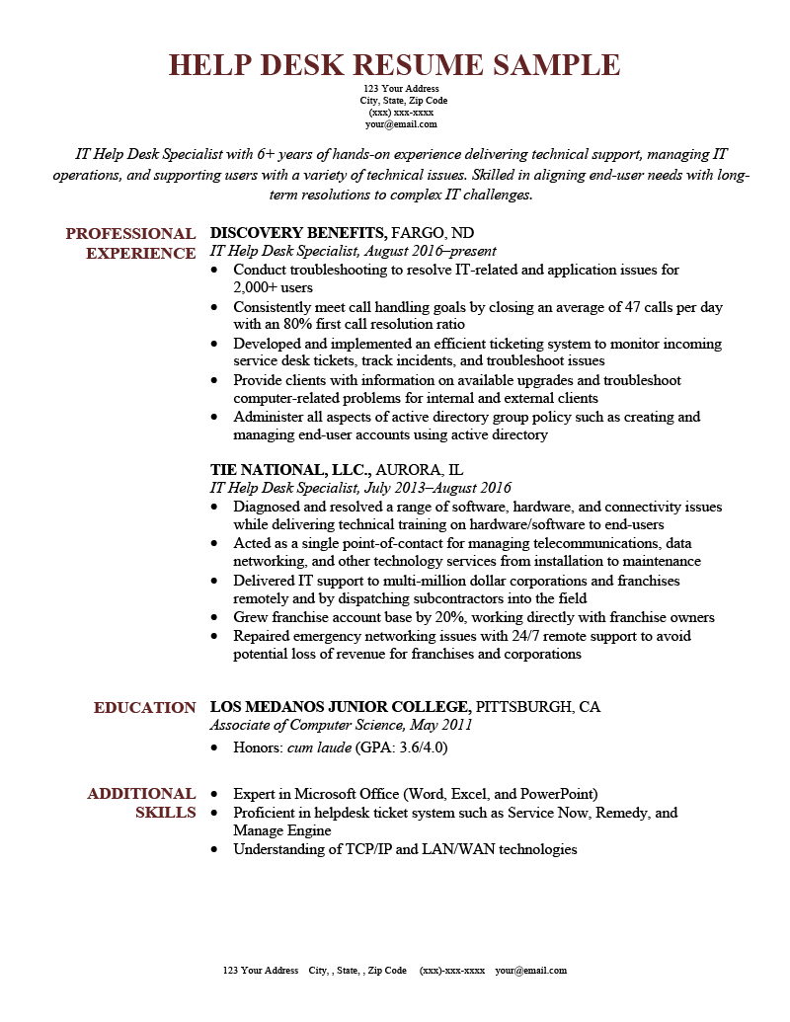
HELP DESK RESUME SAMPLE
123 Your Address
City, State, Zip Code (XXX) XXX-XXXX your@email.com
IT Help Desk Specialist with 6+ years of hands-on experience delivering technical support, managing IT operations, and supporting users with a variety of technical issues. Skilled in aligning end-user needs with long- term resolutions to complex IT challenges.
PROFESSIONAL DISCOVERY BENEFITS, FARGO, ND EXPERIENCE IT Help Desk Specialist, August 2016-present
• Conduct troubleshooting to resolve IT-related and application issues for 2,000+ users
• Consistently meet call handling goals by closing an average of 47 calls per day with an 80% first call resolution ratio
• Developed and implemented an efficient ticketing system to monitor incoming service desk tickets, track incidents, and troubleshoot issues
• Provide clients with information on available upgrades and troubleshoot computer-related problems for internal and external clients
• Administer all aspects of active directory group policy such as creating and managing end-user accounts using active directory
TIE NATIONAL, LLC., AURORA, IL
IT Help Desk Specialist, July 2013-August 2016
• Diagnosed and resolved a range of software, hardware, and connectivity issues while delivering technical training on hardware/software to end-users
• Acted as a single point-of-contact for managing telecommunications, data networking, and other technology services from installation to maintenance
• Delivered IT support to multi-million dollar corporations and franchises remotely and by dispatching subcontractors into the field
•
Grew franchise account base by 20%, working directly with franchise owners • Repaired emergency networking issues with 24/7 remote support to avoid potential loss of revenue for franchises and corporations
EDUCATION LOS MEDANOS JUNIOR COLLEGE, PITTSBURGH, CA Associate of Computer Science, May 2011
⚫ Honors: cum laude (GPA: 3.6/4.0)
ADDITIONAL • Expert in Microsoft Office (Word, Excel, and PowerPoint) SKILLS⚫ Proficient in helpdesk ticket system such as Service Now, Remedy, and Manage Engine
• Understanding of TCP/IP and LAN/WAN technologies
123 Your Address City,, State, Zip Code (XXX)-XXX-XXXX your@email.com

